Online help for English writing
Click on the icon for help on your text
 |  |  | 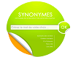 | 
Spell check | Conjugator | Dictionary | Synonyms | Vocal Synthesis
Workspace

